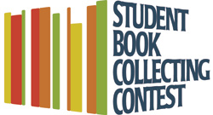
2014 Betty and Edgar Sweren
Student Book Collecting Contest
Johns Hopkins University, The Sheridan Libraries

Full Name:

Status: Undergraduate Student Graduate Student

Class (For Undergraduate Student only):

School (AS, EN, etc): Major:

Current Address:

Permanent Address:

Phone: Email:

Have you entered the Student Book Collecting Contest before? Yes No
If yes: What was the title of your entry and what year did you enter?

How did you hear about the contest?
Today’s Announcement JHU Newsletter Library Website Posters Flyers
Faculty Member Other (Please Specify. Thank You!) _________________________

If selected as an award recipient, I understand that I may be asked to display selected works from my collection in an exhibit in the library or on the library’s website.

Signature:

Date:

